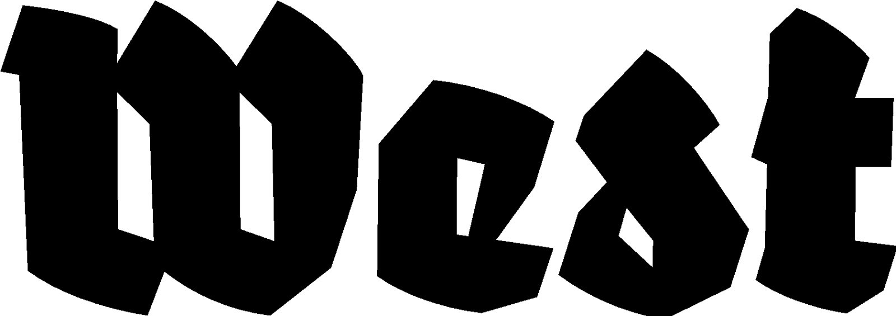

Persbericht 07.08.2024

BOILER ROOM
Charles van Otterdijk

Exhibition: 07.09.2024 — 10.11.2024 Opening: 07.09.2024, 20:00 hrs.
Location: West Den Haag in the form. American Embassy, Lange Voorhout 102, The Hague

For his most recent project, BOILER ROOM, Charles van Otterdijk withdrew himself from the art world for years, to immerse himself in the world of Dutch drug laboratories. Now he returns for the first time with an installation around his extensive research into the illegal, and often dangerous production of synthetic drugs.

The southern part of the Netherlands has become one of the world’s largest production sites
for synthetic drugs. At the same time, Southeast Brabant is also one of the most important
research and production sites for the high-tech industry in Europe. According to a
conservative estimate by Tilburg University, the sales value of ecstasy and amphetamine
produced in the Netherlands is at least as high as the annual turnover of ASML, the most valuable tech company in Europe.

The artist himself grew up in De Peel region on the border between Noord-Brabant and
Limburg, an area where in the past many labs could be found for the production of anabolic
steroids, first for livestock and later also for humans. Currently, the area is considered a
major production site for xtc, and crystal meth is on the rise.

Charles van Otterdijk’s new project began during the Trump era after the artist reread the still-urgent classic ‘Brave New World’ by Aldous Huxley. In the book, children are born and raised in laboratories, but the lab is also a place where recreational drugs, called ‘Soma’, are produced to keep the citizens peaceful and happy. Throughout the years, the artist visited various active drug laboratories. By accident, he discovered a place that turned out to be a training room where young people were schooled in drug production. At about the same time, Van Otterdijk read about a gang that had blown up many ATMs, mostly in Germany. When this gang, better known as the Audi gang after the type of getaway car the gang used, was busted, an instruction shed was discovered where people could practice the ATM robberies. The shed was equipped with a real ATM, solely for this purpose. This ‘instruction lab’, which Van Otterdijk had seen by accident, became the guideline for his project. He shows photos that he managed to take in a still producing drug laboratory, and lab equipment developed and produced by the artist himself. With these lab-elements, the artist could eventually open his own ‘instruction-laboratory’ for the production of synthetic drugs. The first results are now presented in West Den Haag.

Charles van Otterdijk previously retreated to the borders of ​​Germany, Poland and the Czech Republic to investigate places where people had withdrawn from society. There he came across what he suspected to be an illegal military base. This resulted in the ‘Double Centre’ project (2009-2017), which was shown a.o. at Stroom, The Hague; Van Abbemuseum, Eindhoven; Künstlerhaus Bethanien, Berlin; Kaohsiung Museum of Fine Arts, Kaohsiung and Stedelijk Museum Bureau Amsterdam. Previous work was shown a.o. at NICC, Antwerp; CIAP, Hasselt and TENT in Rotterdam.

For more information, please contact us: info@westdenhaag.nl or +31(0)70.3925359

The West program is made possible by, among others: Mondriaan Fund, the Municipality of The Hague and the Ministry of Education, Culture and Science.

